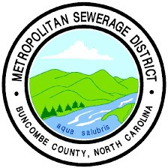
Metropolitan Sewerage District of Buncombe County Industrial Waste Program
Wastewater Best Management Practices

Fermented Beverage Manufacturers Best Management Practices (BMPs)

BMPs Protect the Sewer System – and your bottom line
MSD’s Industrial Waste Department works with industries to make sure their wastewater is properly treated and meets requirements. This protects people, the environment, and the economy.
Wastewater from breweries contain higher concentrations of organic matter than typical household wastewater. Businesses that send concentrated waste to the sewer system pay an extra surcharge fee because it costs more to treat this water.
To help breweries meet requirements and manage costs, MSD has developed these BMPs for brewery wastewater. BMPs are activities, procedures, and features designed to minimize pollutants discharged to the sanitary sewer or released to the environment.

The Requirements
- Meet discharge limits: All breweries that send their wastewater to the MSD Sewer System must make sure their wastewater meets the local discharge limits and prohibitions, summarized here and listed in The MSD Sewer Use Ordinance.
  - Solids: Food waste, including food-grinder waste, must be capable of passing through a 1/4-inch sieve. Solids can restrict or block flow in sewer lines. A company or facility that discharges solids that causes a sewage backup is liable for any damages.
  - pH: The pH of wastewater must remain between 6.0 and 10.5 s.u. Wastewater that is too acidic or too alkaline can seriously corrode the sewer system, so the pH must be balanced.
  - Temperature: Wastewater must not exceed 60° Celsius (140° degrees Fahrenheit) at the point where it enters the MSD Sewer System. Brewery wastewater that is high in temperature can be a concern at MSD’s Water Reclamation Facility.

- Apply for authorization, if needed: Some businesses need permits or authorization to send their wastewater to the sewer. Breweries must apply for authorization if they meet the following criteria:
  - Send 2,000 or more gallons of wastewater to the sewer each day.

- Install a monitoring point, if needed: To ensure their wastewater meets requirements, breweries that need formal authorization must have an easily accessible monitoring point. They must be able to collect samples that represent the discharge from the brewing operation in a location that is separate from sanitary and restaurant drains. (See Figure 1) While small breweries may not always have a separate monitoring point, MSD reserves the authority to require one. In the past, breweries that grew large enough to need formal authorization have had to remodel and replace plumbing to meet requirements.

Figure 1: Monitoring point is needed to sample brewery wastewater only, not other sources of wastewater.
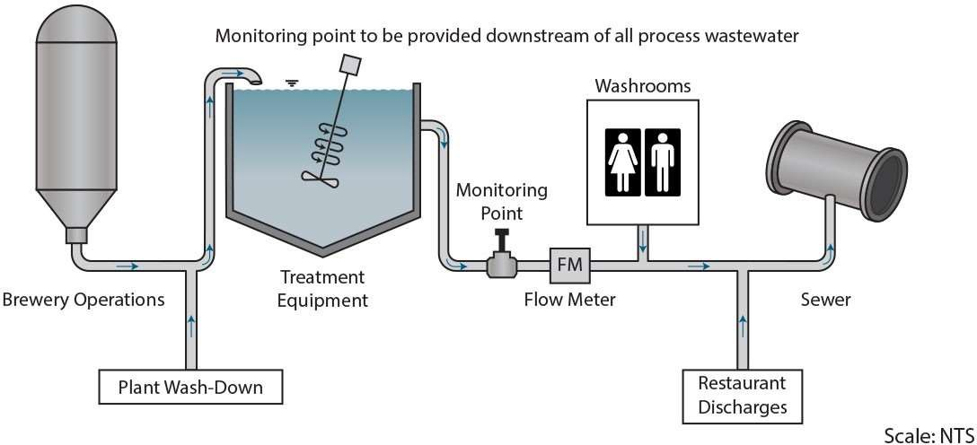

T he BMPs
The following BMPS are recommendations to help large and small breweries meet requirements. Small breweries may be able to meet requirements without implementing every BMP.

S olids Management
Brewery operations must maintain compliance with MSD’s local limits. Industrial wastewater cannot contain substances that could restrict or block flow in sewer lines. Food waste, including food-grinder waste, must be capable of passing through a 1/4-inch sieve. Wastewater discharged to MSD’s Sewer System must not exceed 4,000 mg/L Total Suspended Solids, unless otherwise specified on an Industrial User Permit.
Tips for maintaining compliance with MSD’s solids limits and prohibitions:
- Install screens, filters or baskets on all floor drains and trenches to capture solids.
- Prevent spent yeast, grains, hops, and trub from entering the sewer. Collect them from all filters, mash tuns, whirlpools, and kettles by settling, straining, screening or filtering them. Prevent them from entering the sanitary sewer.
Beneficial reuse
When disposing solids offsite, consider beneficial reuse. Seek opportunities to turn your solids and high strength waste into compost, fertilizer, animal feed, energy, or another authorized beneficial reuse
- Use the correct gauge screen to maximize solids removal and install screens that are easy to access and service.
- Dewater collected solids and dispose off-site. Consider beneficial reuse.
- Collect spent yeast slurry for offsite disposal or beneficial reuse. If possible, reuse the yeast for multiple
generations. This is important because spent yeast slurry from fermentation/maturation tanks has high nutrient and high solids content. Large quantities of yeast lead to organic acids formation, which affect the pH (makes the effluent more acidic).
- Collect used filter media and dispose off-site or consider beneficial reuse.
- Control solids at the source; don’t let the solids hit the ground, sweep up and collect spills, and avoid rinsing them down the drain.
- Train employees on solids management practices.

C ontrol pH
In general, brewery wastewater is acidic. However, cleaning processes can cause high and low spikes. Brewery operations must maintain compliance with MSD’s pH discharge limits, which state that any wastewater having a pH less than 6.0 s.u. for any period, or greater than 10.5 s.u. for any period, or having corrosive properties is prohibited from being discharged to the sanitary sewer.
Tips for maintaining compliance with the pH limits – (see Figures 2 and 3 at the end of this document)
- Install totes, tanks or containers to adjust the pH of individual waste streams.
- Install a sufficiently sized tank to collect wastewater from all brewery operations for the purpose of self- neutralization and, if necessary, to adjust the pH to meet these limits.
- For small batches with slight excursions above pH 10.5, mild acids such as acetic acid (i.e., vinegar) or citric acid can be used to neutralize the wastewater.
- For small batches with slight excursions below pH 6.0, mild alkaline solutions, such as calcium carbonate (lime) can be used to neutralize the wastewater.
- Stronger acidic or alkaline neutralization chemicals may be needed based on the pH of the effluent and the volume of the wastewater to be neutralized.
- Provide a mechanical mixer in the wastewater tank to promote self-neutralizing of low and high pH wastewaters. Please note that adequate mixing is essential when using neutralizing chemicals.
- Reuse and recycle chemicals wherever possible through automated approaches (e.g., clean in place).
- Train employees on effluent pH management practices.

P roduct Losses/Off-Spec Product
Sending excessive amounts of high strength waste to the sewer can disrupt the sewer system and/or increase your high strength surcharge fees. Minimize the volume of unused and off-spec product discharged to the public sewer whenever possible. If there is no other alternative than the sewer, the discharge must meet MSD’s local limits.
In addition to collecting spent yeast, grains, hops and trub, collect the following high strength wastes and dispose off-site. Consider beneficial reuse for disposal:
- Off-spec and unused product
- Tank heels and initial rinse of brew tanks
- Beer & yeast lost in racking and transfer
- Beer lost in filtering, bottling, & kegging

C hemical Storage and Spill Prevention
Provide secondary containment for chemical solutions such as cleaning and sterilization chemicals and waste materials to prevent the entry of these materials into the MSD Sewage System in case of accidental spills.
- Store chemical solutions in low traffic areas, away from forklifts and other production activities, to lessen the chance of an accidental spill.
- Segregate and securely store non-compatible chemicals (for example acids and bases) in separate containment areas to prevent mixing of incompatible or reactive materials.
- Maintain and inspect all process solution tanks on a regular basis and repair any leaks promptly.
- Label all chemical solution storage containers.
- Develop a spill response plan and train employees to follow the spill plan. Post the spill plan and the contact information for spill notification in a prominent place. The plan should at a minimum:
  - Describe where chemicals are stored, how liquids are stored and handled to prevent and isolate spills, and transfer protocols.

  - Describe how staff will respond to a spill, including immediate notifications to emergency responders and MSD Wastewater Treatment Division:
    - M-F, 8 a.m. – 5 p.m.: Industrial Waste Department:
      - Chad Ledford 828-225-8225
      - Shannon Bergeron 828-225-8230
    - After 5 p.m. and on weekends:
      - MSD Operator Control Room: 828-225-8228
      - MSD Operator Cell Phones: 828-768-0213 or 828-768-0801
  - Describe staff training required to respond to spills safely and effectively.
  - Update the plan as your processes change.

R ecords
Keep records to document your facility’s compliance with requirements.
- Maintain records documenting off-site waste removal including waste stream, volume, date, and method of disposal of accumulated wastes.
- Maintain records of all effluent sample results collected to determine compliance with MSD local limits.
- Retain records on site for a minimum of three years.

C onsiderations When Planning for New or Remodeled Operation
Avoid expensive mistakes! When working on your facility layout, retain the services of an engineer experienced in design of brewery wastewater treatment systems and consider the following:
- All drains from brewing operations should lead to a common drain, sump or wastewater tank where the wastewater can be accessed and managed to ensure compliance with discharge limits.
- Control of pH is often necessary, and batch treatment to meet pH limits is still the best option for many small breweries. Necessary features typically include a tank, mixer, pH meter in tank (to control neutralizing chemicals), continuous pH meter (for the discharge), and a delivery system for the acids and bases used for neutralization. (See Figures 2 and 3 at the end of this document)
- Set aside sufficient floor space for a wastewater pH equalization / treatment tank, treatment chemical containers, and solids handling equipment and storage.
- Provide an easily accessible sample site that is representative of the discharge from the brewing operation, separate from sanitary and restaurant drains. (See Figure 1)
- Consider the method(s) and/or equipment you will use to measure wastewater discharge volume from the brewing operation.

W ater Conservation
Conserving water can reduce wastewater and save money. Ways to conserve water include:
- Monitor your water usage by installing water meters in various areas of the operation; establish a baseline and set water saving goals.
- Use dry clean-up procedures prior to wet clean-up.
- Use water-efficient equipment, such as high-pressure nozzles, clean-in-place systems, and water brooms. Find alternatives to water-cooled chilling equipment.
Additional examples of water conservation BMPs can be found in such documents as the Brewers Association’s
Water and Wastewater: Treatment/Volume Reduction Manual.

Figure 2: pH neutralization for flow-through or multiple batch

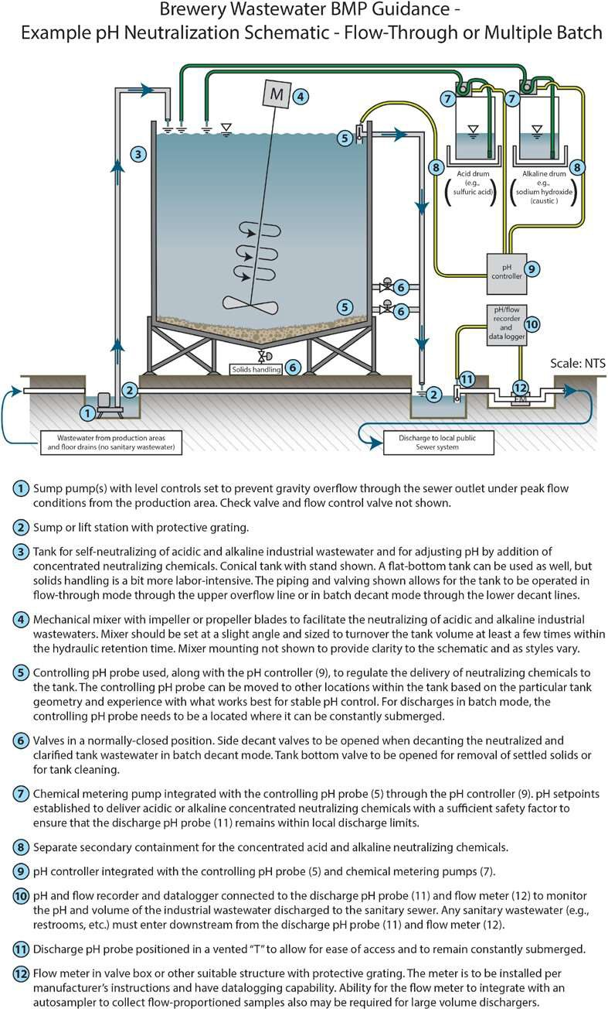

Figure 3: pH neutralization for a single daily batch
